**Developer Guide**

**Security Starter Kit with STM32WB55 and OPTIGA™ Trust M**

Date: March 03, 2021 | Version 1.1



Contents

1 Introduction 4

1.1 Purpose of the Document 4

1.2 Architecture 4

1.3 SSK Suit Package Contents 4

2 Setting up THE development environment 5

2.1 Hardware setup 5

2.2 Software Setup 6

2.2.1 STM32CubeIDE 6

2.2.2 STM32CubeProgrammer 6

2.2.3 OpenSSL 6

2.2.4 AWS CLI 6

2.2.5 Terminal emulator 6

2.2.6 Android studio or Xcode 6

2.3 OTA configuration in AWS 7

2.4 Mobile App setup 7

3 Integration of AWS FreeRTOS and OPTIGA™ Trust M 14

3.1 AWS Sources 14

3.2 OPTIGA™ Trust M Source 14

3.3 Mutual Authentication Source 14

4 Code Compilation and Binary Flashing 17

4.1 Code Compilation Steps 17

4.2 Binary flashing 20

5 Setup AWS IoT Thing On AWS Console 23

6 MQTT Demo 27

6.1 Setup AWS config in the STM32WB55 Source Code 27

6.2 Run MQTT Demo 28

7 OTA DEMO 31

7.1 Setup AWS config in the STM32WB55 Source Code 31

7.1.1 OTA Firmware Version upgrade 32

7.1.2 AWS configuration for OTA Job 33

7.2 Run OTA Demo 38

8 References 41

Definition, Acronyms and Abbreviations

|  |  |
| --- | --- |
| **Definition/Acronym/Abbreviation** | **Description** |
| AWS | Amazon Web Services |
| AWS CLI | AWS Command Line Interface |
| BLE | Bluetooth Low Energy |
| DFU | Device Firmware Update |
| FUS | Firmware Update Service |
| MQTT | Message Queuing Telemetry Transport |
| OTA | Over-the-Air |
| SSK | Security Starter Kit |
| STM | STMicroelectronics |

# Introduction

## Purpose of the Document

This document describes how to integrate the AWS FreeRTOS, BLE, MQTT and OPTIGA™ Trust M stack on STM32WB55 board. The AWS basic demo is also covered, which securely communicates with AWS Cloud using OPTIGA™ Trust M chip. This document will also guide the user through the AWS IoT console features to understand the Amazon IoT web services.

## Architecture

The STM32WB55 board has Bluetooth Low Energy (BLE) as the wireless interface. A proxy or gateway will be required to access AWS services to gain internet connectivity via Wi-Fi or Ethernet. In this case, a mobile device (either Android or iOS) having BLE and 4G (or Wi-Fi) connectivity will facilitate as gateway. An Android or iOS Mobile application will act as a proxy between BLE and another network.

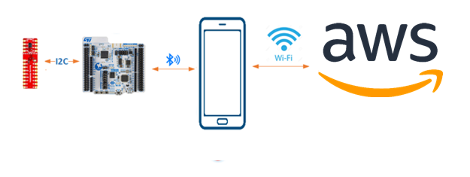

Figure 1: Hardware Setup

## SSK Suit Package Contents

1. Download the SSK STM32WB55 release package - [Security-Starter-Kits-STM32WB55-SSK.zip](https://github.com/ArrowElectronics/Security-Starter-Kits/tree/STM32WB55-SSK) from the Arrow Electronics GitHub portal

* Extract the [Security-Starter-Kits-STM32WB55-SSK.zip](https://github.com/ArrowElectronics/Security-Starter-Kits/tree/STM32WB55-SSK)
* Extracting the zip file, one will find the below contents:
  + [STM32WB55-SSK Developers Guide.pdf](https://github.com/ArrowElectronics/Security-Starter-Kits/tree/STM32WB55-SSK)
  + [STM32WB55-SSK Quick Start Guide.pdf](https://github.com/ArrowElectronics/Security-Starter-Kits/tree/STM32WB55-SSK)
  + Firmware_Images
  + Source_Code
  + SSK_Cert_And_Config
  + Andriod-APP.zip
  + IOS_APP.url

# Setting up THE development environment

## Hardware setup

The following hardware is needed for this project:

* STM32WB55 board from ST’s P-NUCLEO-WB55 package
* Infineon’s Shield2Go OPTIGA™ Trust M
* Custom cable to connect the OPTIGA™ Trust M to the STM32WB55 board
* Micro USB cables to Power on the Board. The same cable is used for debugging.
* IOS or Android Mobile Device (As a Proxy or Gateway)
* A development PC or Mac for either Android or iOS application compilation.

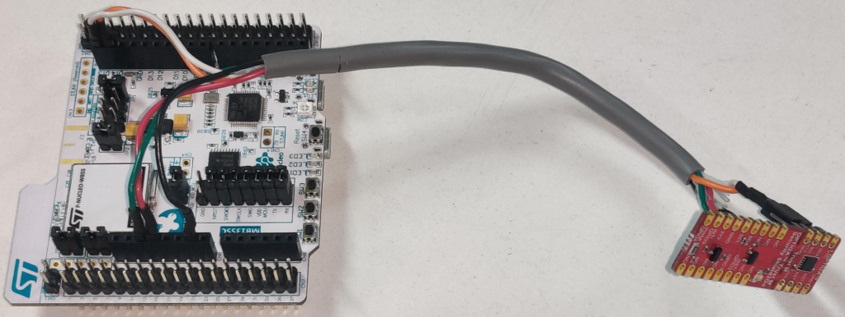

Figure 2: Hardware Setup

1. Please make sure that the below shown jumpers are connected on STM32WB55 board.

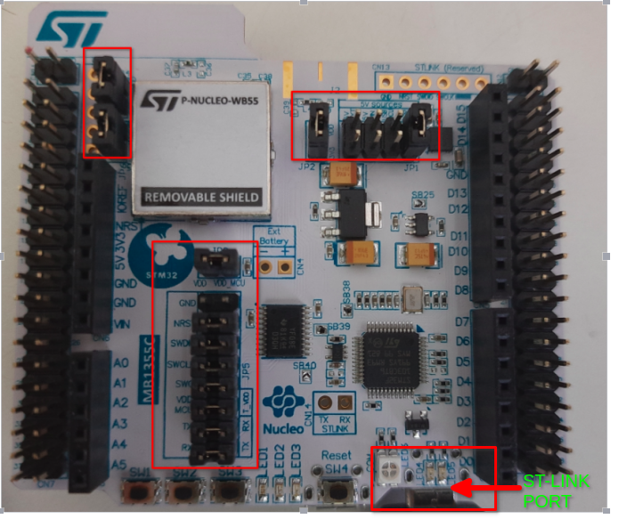

1. Connection between OPTIGA™ Trust M with STM32WB55 board using the ribbon cable as per below table.

|  |  |  |
| --- | --- | --- |
| Connections No | OPTIGA™ TrustM | STM32WB55 |
| 1(Red) | VCC | CN6.4 (+3v3) |
| 2(Black) | GND | CN6.6 (GND) |
| 3(Green) | RST | CN6.3 (NRST) |
| 4(White) | SCL | CN5.10(D15) |
| 5(Orange) | SDA | CN5.9(D14) |

1. Connect Micro USB cable to ST-LINK (port) as show in figure to power on the board and for debugging purposes.

## Software Setup

### STM32CubeIDE

STM32CubeIDE is software tool to compile the source code and generate the binary to flash on the STM32WB55.

* Download and Install STM32CubeIDE from ST site:

<https://www.st.com/en/development-tools/stm32cubeide.html>

### STM32CubeProgrammer

STM32CubeProgrammer is required to program the Flash memory of STM32WB55 board.

* Install STM32CubeProgrammer from ST site:

<https://www.st.com/en/development-tools/stm32cubeprog.html>

### OpenSSL

OpenSSL is needed for certificate creation if you want to do OTA update.

### AWS CLI

AWS CLI is needed to automate various tasks and import OTA certificates in AWS.

### Terminal emulator

A serial terminal software like **Putty or Minicom** is needed for debugging the Amazon FreeRTOS application running on STM32WB55 (using USB virtual COM port).

### Android studio or Xcode

A software development tool, like Android Studio, to manage Android app or Xcode for IOS Mobile is needed to compile the Amazon FreeRTOS BLE gateway Mobile application.

[**Note**: Source codes are available under Source_Code/Mobile_App_Source.zip]

## OTA configuration in AWS

To perform OTA, user will have to configure the below listed items in the [AWS console](https://aws.amazon.com/console/)

* Check the Prerequisites for OTA updates using MQTT.
* Create an Amazon S3 bucket to store your update.
* Create an OTA Update service role.
* Create an OTA user policy.
* Create a code-signing certificate.
* Grant access to code signing for AWS IoT.

Detailed configuration and steps available on an AWS document here:

<https://docs.aws.amazon.com/freertos/latest/userguide/ota-prereqs.html>

## Mobile App setup

Please follow below steps to create AWS Cognito user. This is needed to login into the Mobile app. It is presumed that the User has AWS Account Login - <https://aws.amazon.com/console/>

.

1. **If you have already created the Amazon Cognito user pool in the AWS console then go to step 6, otherwise continue with step 2.**
2. **To create an Amazon Cognito user pool in AWS Console:**
   * In AWS console, open the **Amazon Cognito** console (Service), and choose **Manage User Pools**.

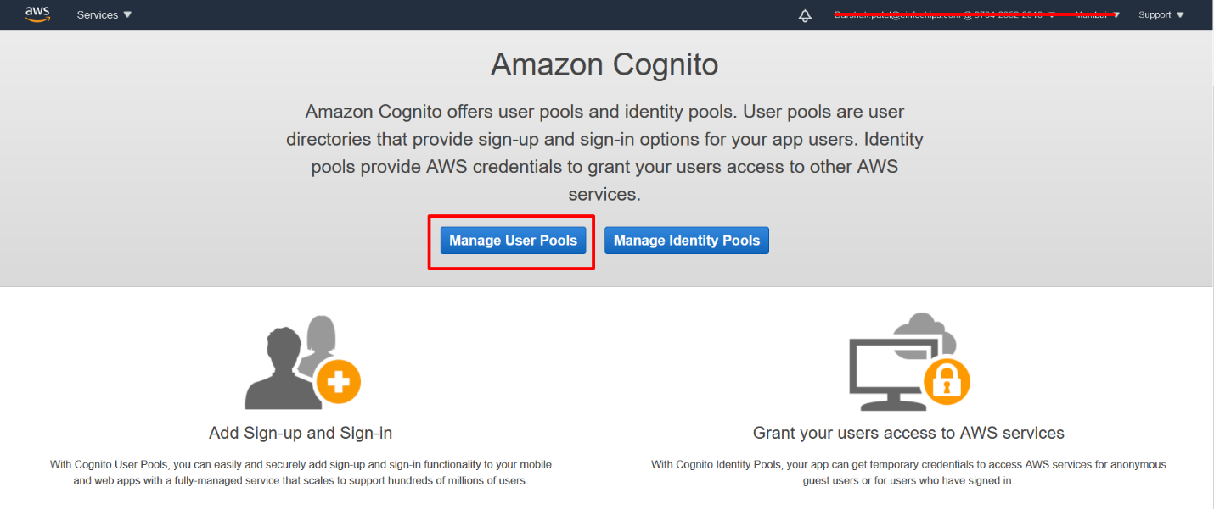

* + Choose **Create a user pool**.
  + Give the user pool a name, and then choose **Review defaults**.
  + From the navigation pane, choose **App clients**, and then choose **Add an app client**.
  + Enter a name for the app client, and then choose **Create app client**.
  + From the navigation pane, choose **Review**, and then choose **Create pool**.
  + Make a note of the pool ID that appears on the **General Settings** page of your user pool.
  + From the navigation pane, choose **App clients**, and then choose **Show details**.
  + Make a note of the app client ID and app client secret.

1. **To create an Amazon Cognito identity pool in AWS Console**
   * In AWS Console, Open the Amazon Cognito console (Service), and choose **Manage Identity Pools**.

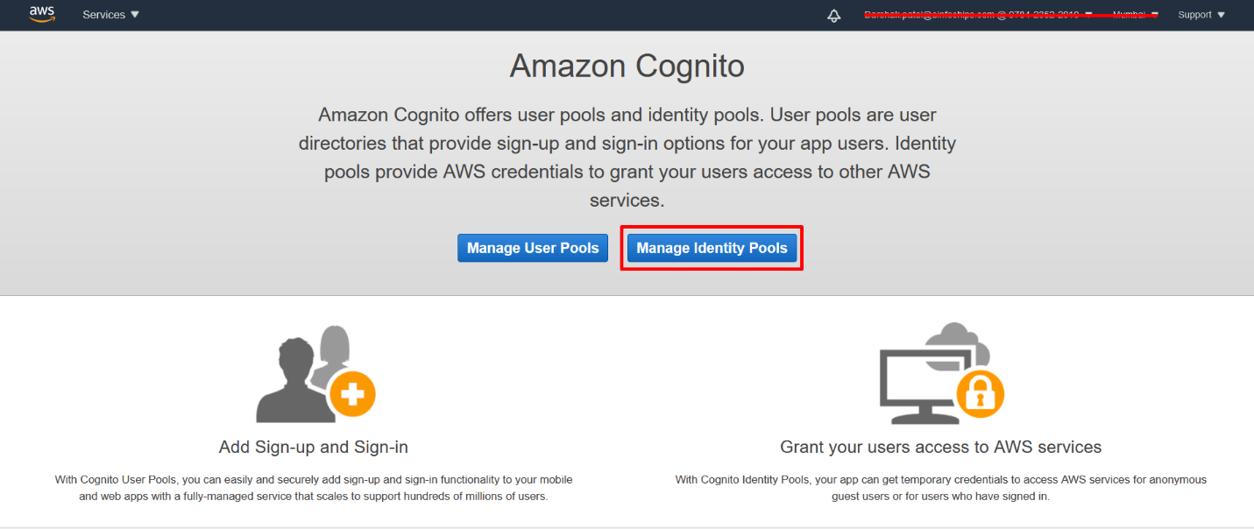

* + Choose **Create new identity pool.**
  + Enter a name for your identity pool.
  + Expand **Authentication providers**, choose the **Cognito** tab, and then enter your user pool ID and app client ID.
  + Choose **Create Pool**.
  + Expand **View Details and** make a note of the two IAM role names. Choose **Allow** to create the IAM roles for authenticated and unauthenticated identities to access Amazon Cognito.
  + Choose **Edit identity pool**. Make a note of the identity pool ID. It should be of the form **us-west-2:12345678-1234-1234-1234-123456789012.**

1. **To create and attach an IAM policy to the authenticated identity:**
   * In AWS console, open the IAM console, and from the navigation pane, choose **Roles**.

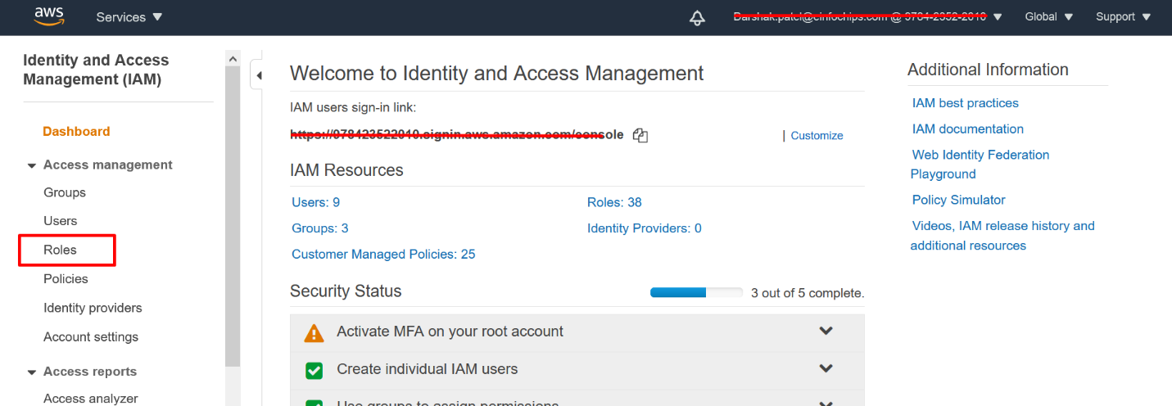

* + Find and choose your authenticated identity's role, choose **Add inline policy**.
  + Choose the **JSON** tab, and paste the following JSON:

|  |
| --- |
| **{**  **"Version":"2012-10-17",**  **"Statement":[**  **{**  **"Effect":"Allow",**  **"Action":[**  **"iot:AttachPolicy",**  **"iot:AttachPrincipalPolicy",**  **"iot:Connect",**  **"iot:Publish",**  **"iot:Subscribe",**  **"iot:Receive",**  **"iot:GetThingShadow",**  **"iot:UpdateThingShadow",**  **"iot:DeleteThingShadow"**  **],**  **"Resource":[**  **"*"**  **]**  **}**  **]**  **}** |

* + Choose **Review policy**, enter a name for the policy, and then choose **Create policy**.

1. **Create New User in Cognito User pool:**

This can be done either from the Android application (login screen) or from the AWS console. In case a confirmation is needed this can be done from the AWS Cognito console (in Users and groups).

* + Login AWS console - <https://aws.amazon.com/console/>
  + **AWS Console >> Cognito Service >> Manage User pool >> Select created user pool**
  + **General Settings >> Users and groups >> Create user**
  + Make a note of the created Username and Password, which is used to login into the Mobile app.

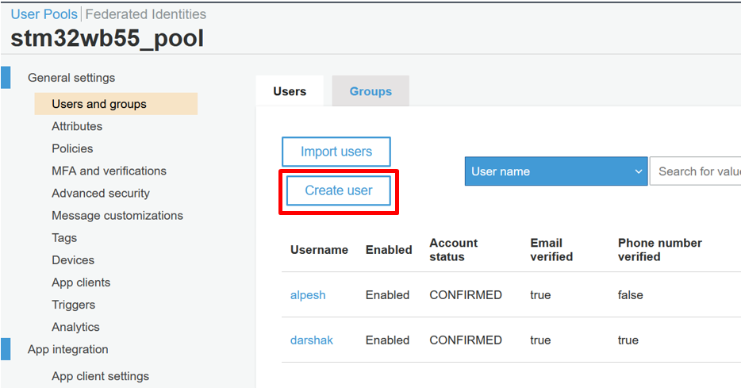

1. **Create an AWS IoT policy**

* Open the [AWS IoT console](https://console.aws.amazon.com/iot/).
* In the navigation pane choose **Secure**, choose **Policies**, and then choose **Create**. Enter a name (**STM32WB55-policy**) to identify your policy. In the **Add statements** section, choose **Advanced mode**. Copy and paste the following JSON into the policy editor window.

|  |
| --- |
| **{**  **"Version": "2012-10-17",**  **"Statement": [**  **{**  **"Effect": "Allow",**  **"Action": "iot:*",**  **"Resource": "*"**  **}**  **]**  **}** |

* Choose **Create**.

**[Note:** Keep your AWS IoT and Amazon Cognito information on hand. You need the endpoint and IDs to authenticate your mobile application with the AWS Cloud**]**

1. **Create a new text file with the name AWS_Config.txt and enter the parameters:**

**AWS_REGION**#<Enter-Region>

**AWS_IOT_POLICY**#STM32WB55-policy

**AWS_COGNITO_IDENTITY_POOLID**#<Enter-Identity-Pool-ID>

**AWS_COGNITO_USER_POOLID**#<Enter-User-Pool-ID>

**AWS_COGNITO_USER_APPCLIENTID**#<Enter-User-App-ID>

**AWS_COGNITO_USER_APPCLIENTSECRET**#<Enter-User-App-SECRET>

1. **Install provided Mobile APK from the Github site below and run it:**

[**https://github.com/ArrowElectronics/Security-Starter-Kits**](https://github.com/ArrowElectronics/Security-Starter-Kits)

1. **Follow for FIRST TIME SETUP ONLY otherwise press “SKIP”:**

Click on “**Browse for the Cognito details**” and upload the **AWS_Config.txt** file, verify the configurations, and then Press “**Save**” button on screen as shown - **First Time configuration screen.**

**First Time configuration screen** **Press Skip or reconfigure if required**

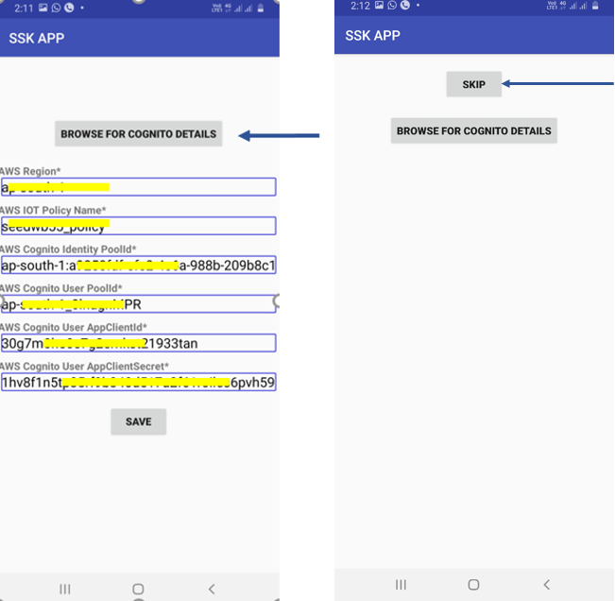

1. **Login in the App using the Cognito user credentials:**

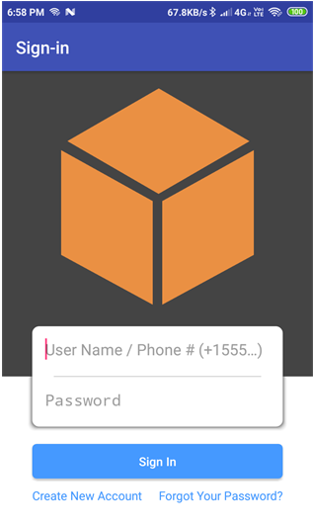

1. **After Successful Login, you should see the below screen:**

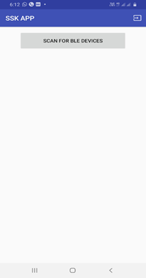

# Integration of AWS FreeRTOS and OPTIGA™ Trust M

## AWS Sources

The Amazon FreeRTOS for STM32WB55 Nucleo software package is an extension of Amazon FreeRTOS and is available at the Github repository.

* It is provided as a Source_Code/STM32WB55_SSK_AWS_Rel with mandatory SLA0078 license acceptation.
* aws_demos: Provides the MQTT and OTA demo. Users can select demos using compilation flags, more details are described in **section 6.1** and **section 7.1.**

## OPTIGA™ Trust M Source

The OPTIGA™ Trust M is a high-end security solution that provides an anchor of trust for connecting IoT devices to the cloud, giving every IoT device its own unique identity. This pre-personalized turnkey solution offers secured, zero-touch onboarding and the high performance needed for quick cloud access.

OPTIGA™ Trust M security chip Software Framework is ported in the provided package, available at: <https://github.com/Infineon/OPTIGA-trust-m>

To port software framework templates, the files shown below must be updated based on your Hardware platform.

1. pal_ifx_i2c_config.c
2. pal_i2c.c
3. pal_gpio.c
4. pal_os_timer.c
5. pal_os_event.c

For reference, please refer to: <https://github.com/Infineon/OPTIGA-trust-m/wiki/Porting-Guide>

## Mutual Authentication Source

Mutual Authentication is the device authentication process, which must be executed before an Application begins to communicate with the AWS cloud. It fails if any unauthenticated devices try to communicate with the mobile app.

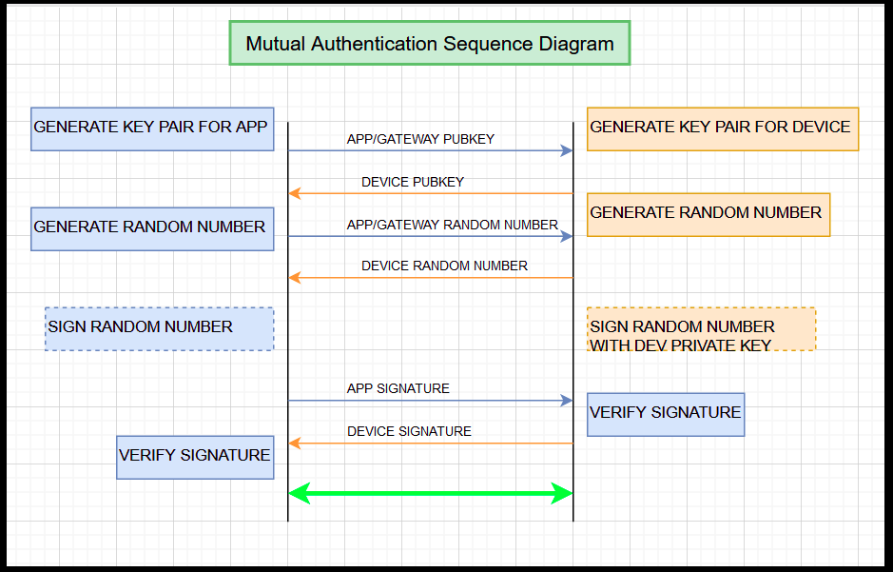

* After completing mutual authentication, the kit generates one secret key, which uses an AES 256 symmetric key to encrypt and decrypt all communications.

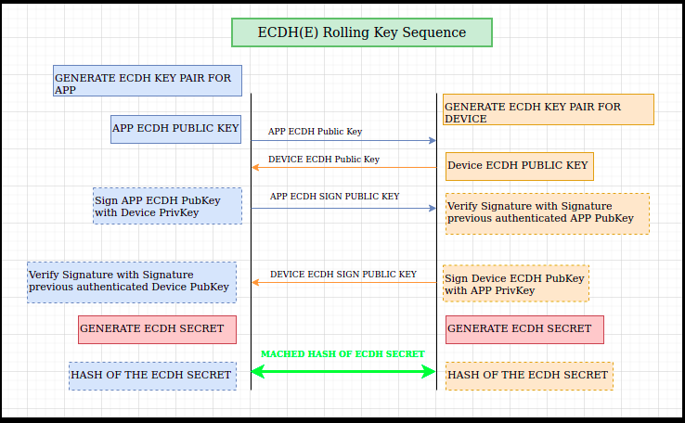

* The SSK uses OPTIGA™ Trust M security chip to store the secrets e.g.: certificates, keys, etc. Also, it uses the hardware crypto library provided by OPTIGA™ Trust M software stack.
* To implement mutual authentication, add one custom BLE service in STM32WB55 AWS source code available at: **SSK_SUIT_EVAL_STM32WB55_Rel_[Release]/Source_code/STM32_SSK_AWS_Rel_[version]/demos/ble/aws_ble_mutual_auth.c**

# Code Compilation and Binary Flashing

## Code Compilation Steps

1. Download and extract the SSK STM32WB55 release package (**STM32WB55_SSK_Pkg_Rel.zip**) from the Arrow Electronics Github portal:

<https://github.com/ArrowElectronics/Security-Starter-Kits>

1. In the extracted directory, the project is available under:

**Source_Code/STM32_SSK_AWS_Rel_[version]/projects/st/p_nucleo_wb55/STM32CubeIDE**

1. Launch the STM32CubeIDE application.
2. Open a workspace under **projects\st\p_nucleo_wb55\STM32CubeIDE**

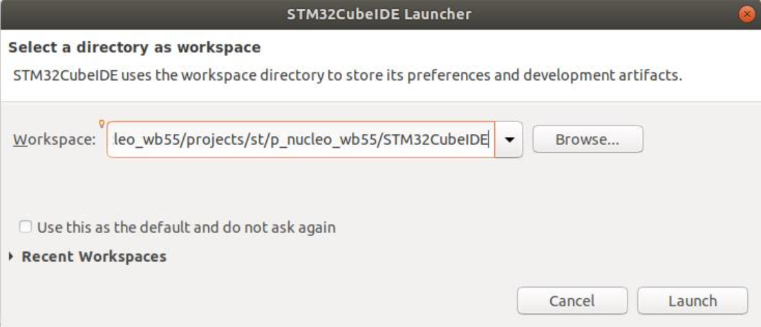

1. Close the Information Center to view the C/C++ perspective.

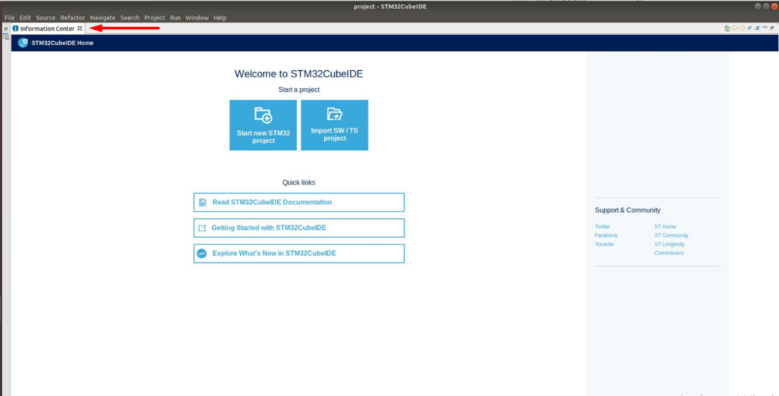

1. Select menu **File >> Open project from File system... >> Finish**

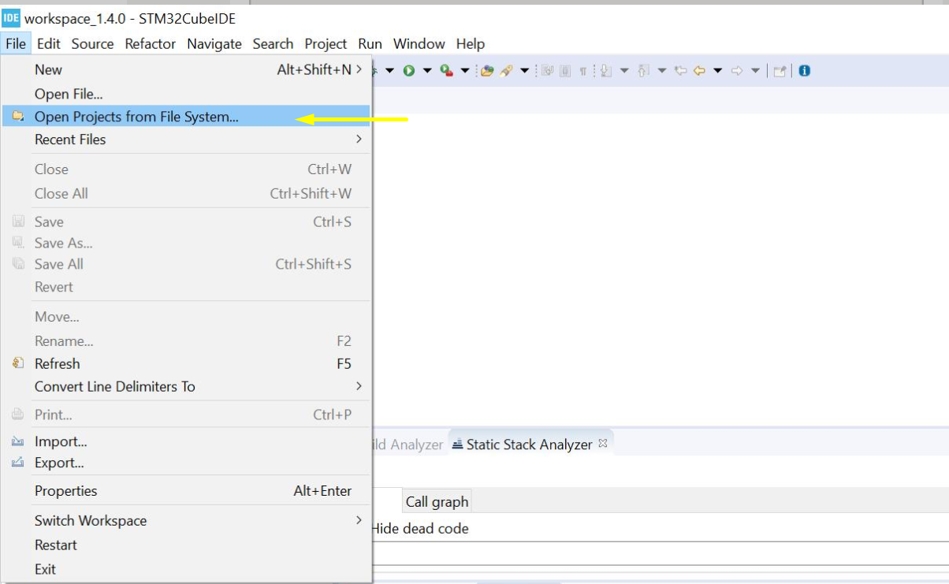

1. In “Select directory” browse to **projects/st/ p_nucleo_wb55/STM32CubeIDE**
2. Import the four projects:
   * STM32WB55RG_Nucleo_2_Images_SECoreBin
   * STM32WB55RG_Nucleo_2_Images_SBSFU
   * STM32WB55RG_Nucleo_AFR_demo
   * STM32WB55RG_Nucleo_AFR_tests

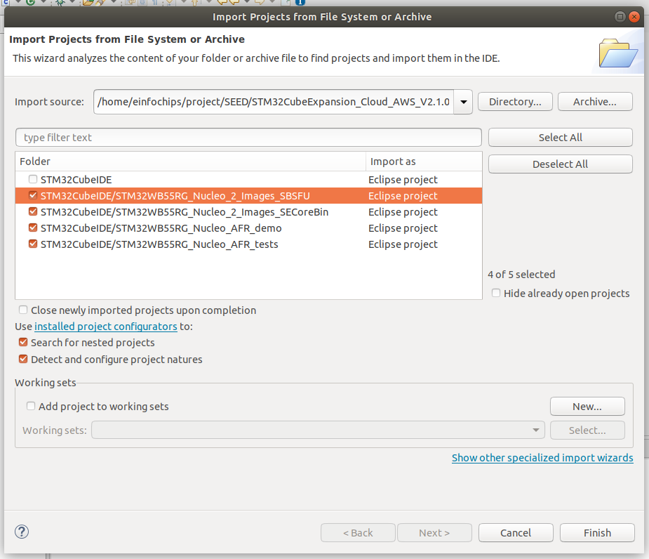

1. For Compilation, you need to follow this sequence:
2. Compile **SECoreBin** first, then **SBSFU**, and then **AFR_demo** to avoid build conflicts. With the console open you can see build messages as shown below:

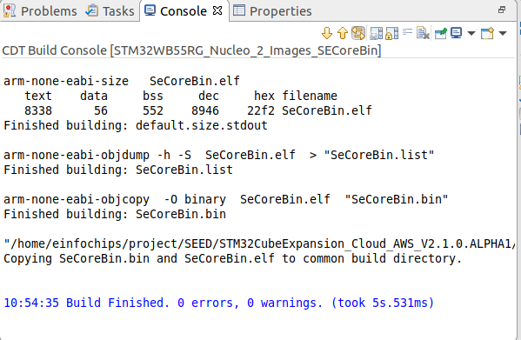

## Binary flashing

Final binaries are located in **Source_Code/STM32_SSK_AWS_Rel_[version]/build** directory.

* SBSFU_aws_demos.bin - bootloader + demo application
* aws_demos.sfb - demo application + OTA update header

1. Plug a USB cable from PC to the STM32WB55 board (Board backside port named "**ST-LINK**")
2. Open STM32CubeProgrammer and click on connect button to connect the board as shown below:

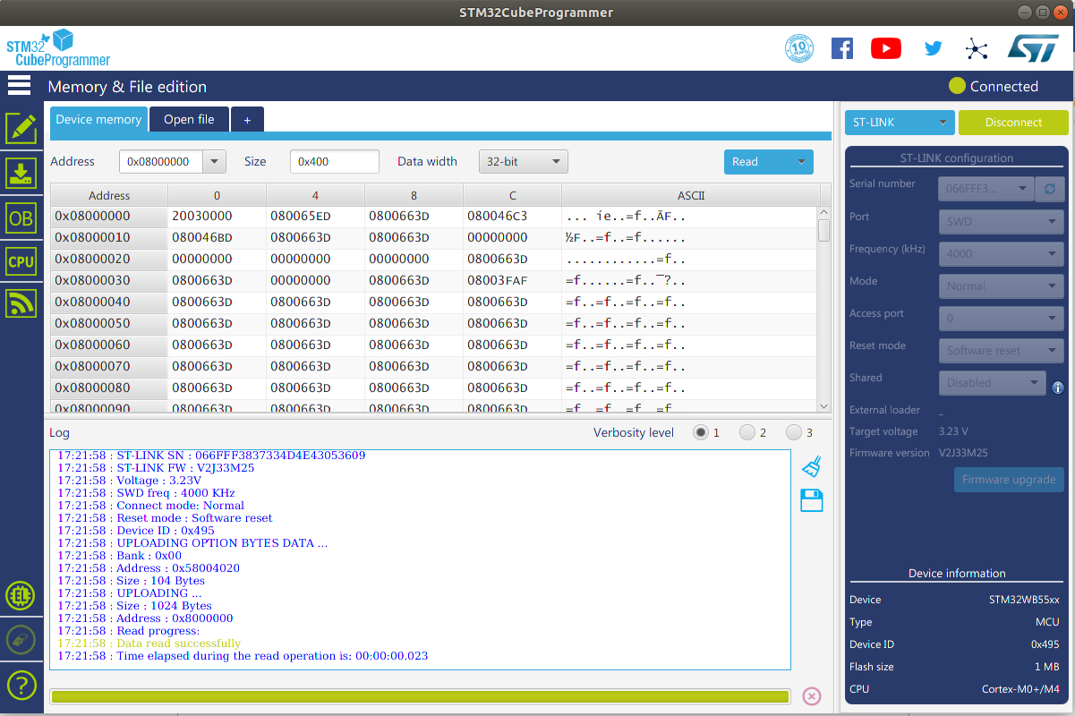

1. First, the Flash memory must be entirely erased as depicted in the screenshot below:

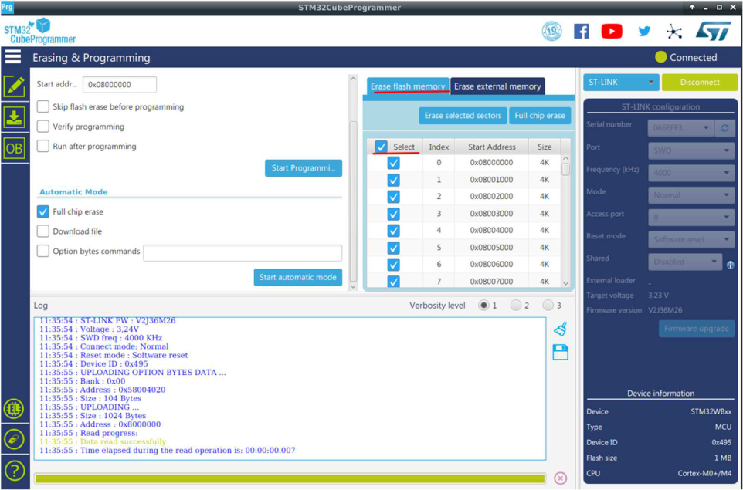

1. Flash the binary (e.g. **build\ SBSFU_aws_demos.bin**) using STM32CubeProgrammer (**address 0x08000000**).
2. After successfully flashing the Binary, you will see a Popup message- “**File Download complete**”. Press **OK**

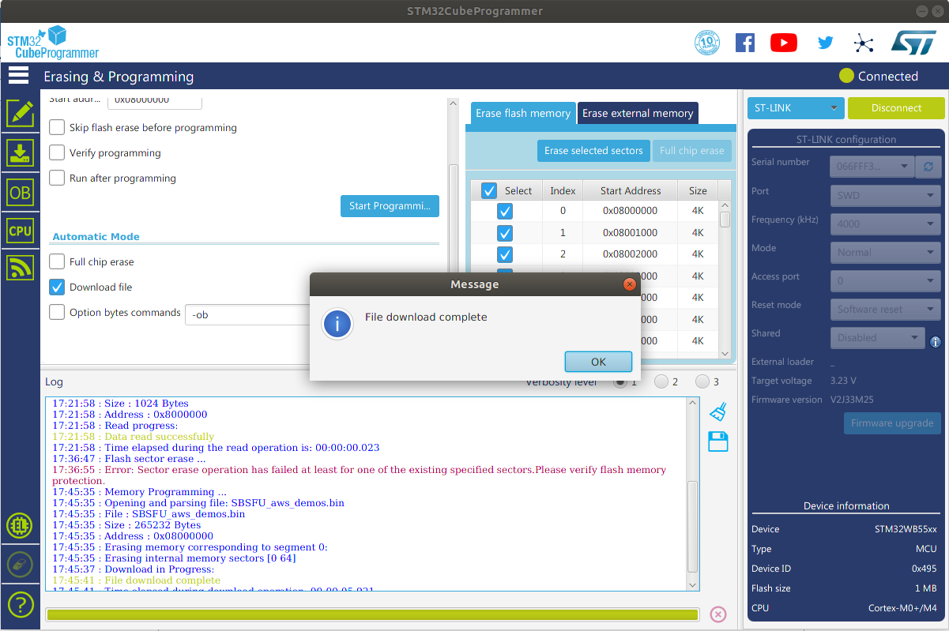

# Setup AWS IoT Thing On AWS Console

1. Open the [AWS IoT console](https://console.aws.amazon.com/iot/), and from the navigation pane, choose **Manage**, and then choose **Things**.

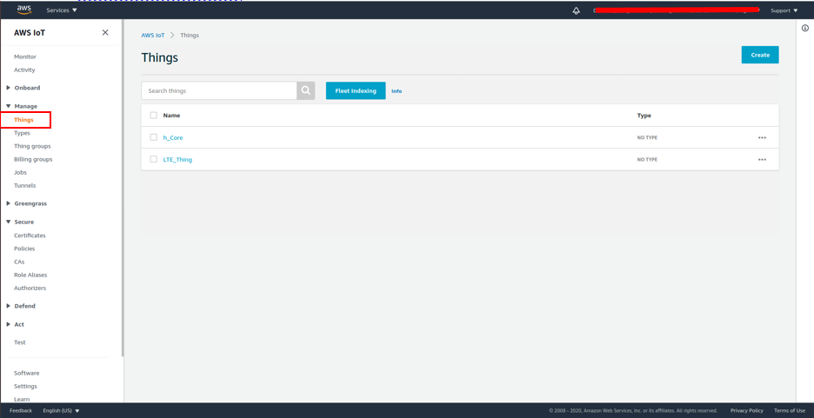

1. Choose **Create**, and then choose **Create a single thing**.

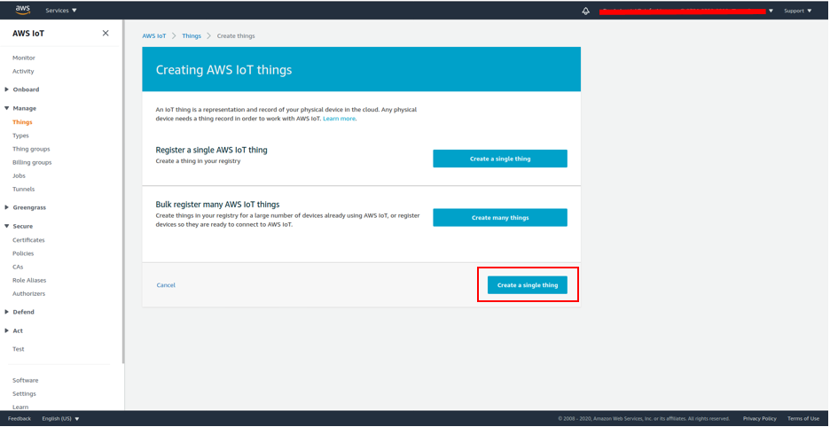

1. Enter a name for your device, and then choose **Next**.

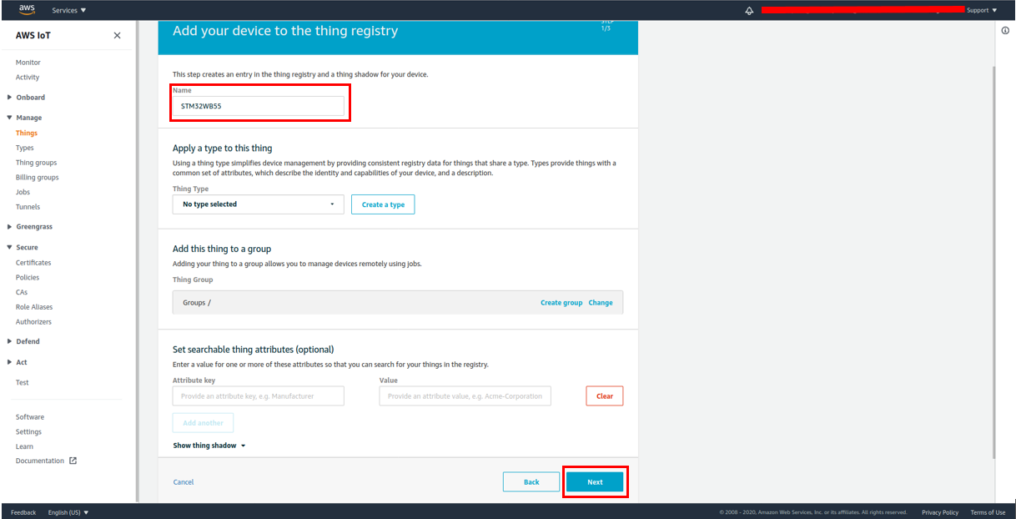

1. If you are connecting your microcontroller to the cloud through a mobile device, choose **Create thing without certificate**. Because the Mobile SDKs use Amazon Cognito for device authentication, you do not need to create a device certificate for demos that use Bluetooth Low Energy.

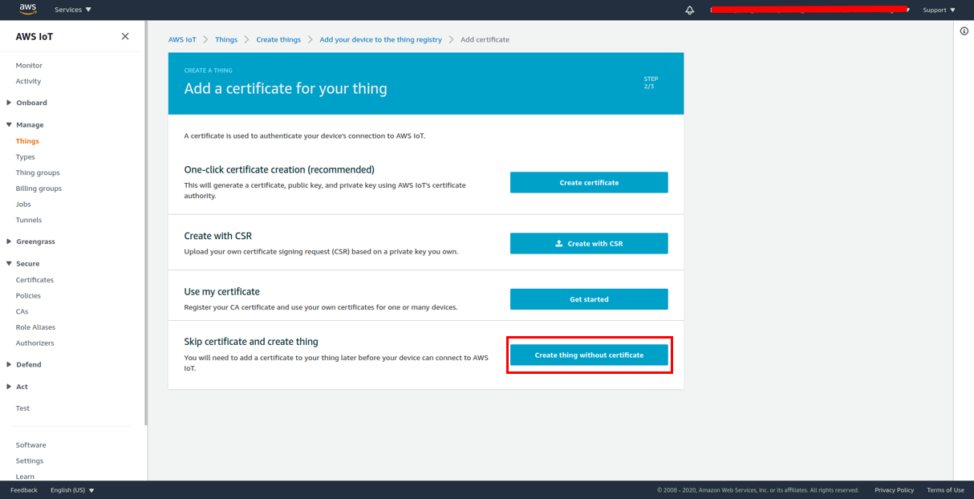

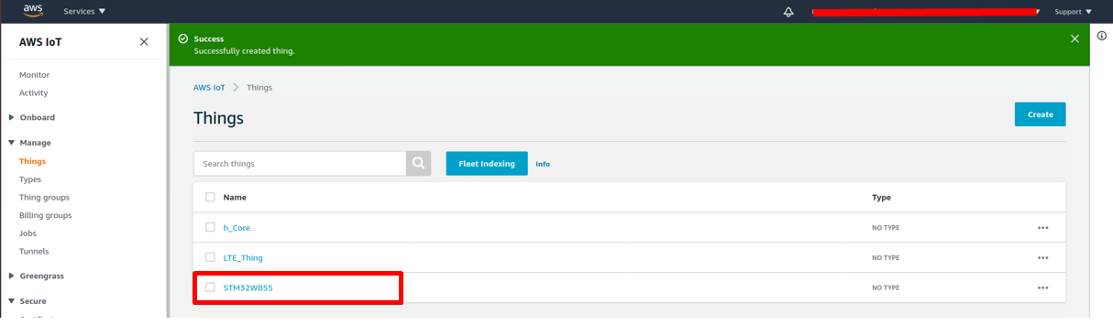

1. In the left navigation panel, choose Settings. Your AWS IoT endpoint is displayed in Endpoint. It should look like: **\*<accountID>*-ats.iot.*<region>*.amazonaws.com**. **Record the endpoint, it is required when you first-time start the board**.

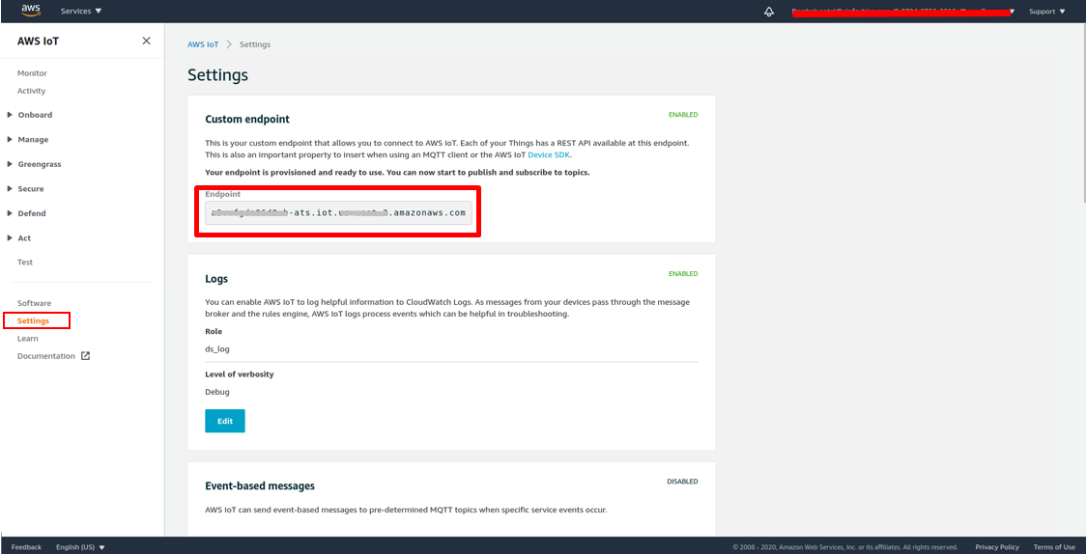

1. In the left navigation pane, choose **Manage** **>>** **Things**. Your device should have an AWS IoT thing name. **Record this name**.

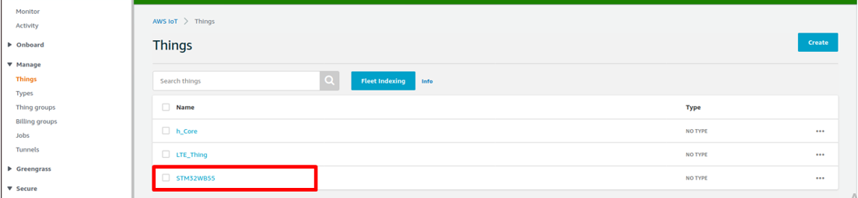

# MQTT Demo

## Setup AWS config in the STM32WB55 Source Code

1. Configure AWS IoT thing name into **demos/include/aws_clientcredential.h** file in IDE and specify values for the following #define **clientcredentialIOT_THING_NAME** **“ST32WB55” (Thing name, created in AWS console)**.

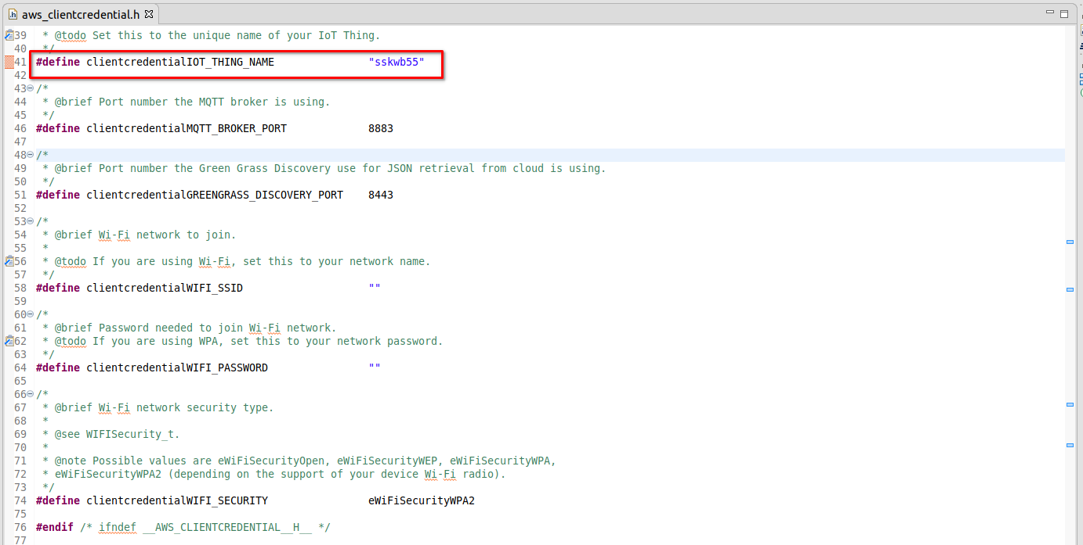

1. Make sure aws_demos are configured for MQTT demo in **config_files\aws_demo_config.h** in CubeIDE (or **vendors\st\boards\p_nucleo_wb55\aws_demos\config_files\aws_demo_config.h**):

#define CONFIG_MQTT_DEMO_ENABLED

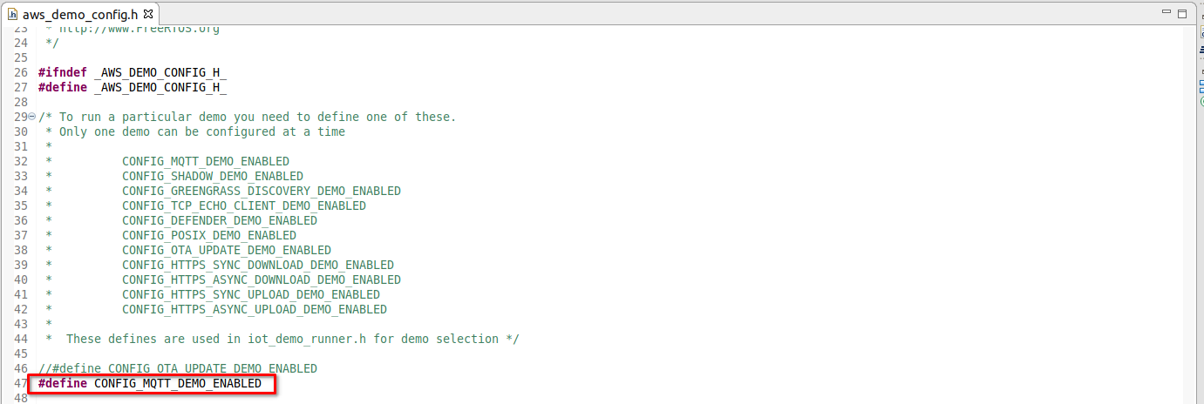

[**Note**: In addition, all the other CONFIG_*_ENABLED flags are commented.]

1. Then compile the **STM32WB55RG_Nucleo_AFR_demo** project as mentioned in the **section 4.1** and Flash the binary on the STM32WB55 board as mentioned in the **section 4.2.**

## Run MQTT Demo

1. If you want to modify the Endpoint URL, then follow the **step 2** otherwise Reset the board and jump to **step 3**.
2. Press the SW2 button and Reset the board (By Pressing “Reset” [SW4] button as shown in figure 2). It will ask the user to enter an endpoint URL in the Serial console screen as below.

Paste the Endpoint URL here and press the “Enter” key on keyboard. (Note: Default Echo is OFF, so cannot see your Endpoint URL value.)

So, to verify that the correct endpoint URL was entered, on the serial console it will display the URL as shown below (with yellow redactions):

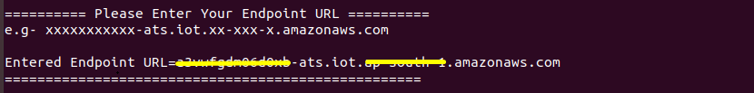

1. Click on the **SCAN FOR BLE DEVICES** button. Connect and Pair with STM32WB55 device. On the serial console Press “Y” if passkey matches with mobile pair key.

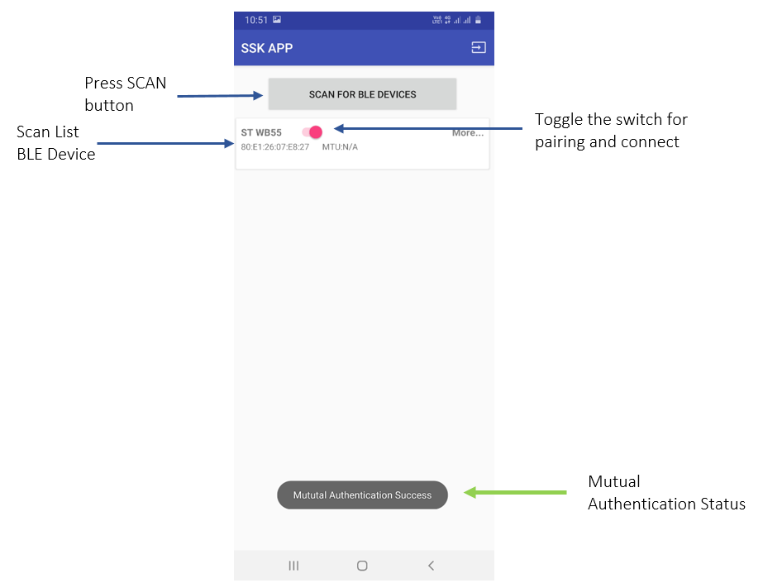

1. During this demo, **Mutual Authentication** is enabled between the Mobile Device and STM32WB55. Only an Authenticateddevice can start communication, otherwise Mutual Authentication fails and logs out from the AWS Cognito Session in the Mobile app.
2. To see the MQTT message on AWS console, **Open AWS Console >> IoT Service >> Test** page and

Subscribe the Topic: **iotdemo/topic/#**

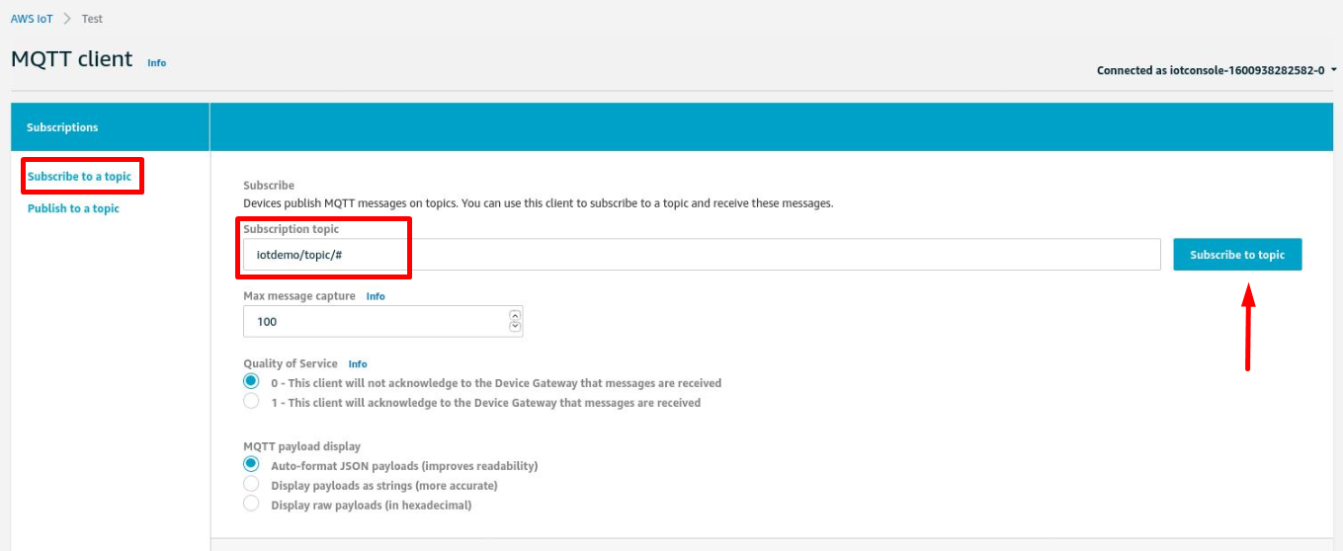

**MQTT Messages on AWS console,**

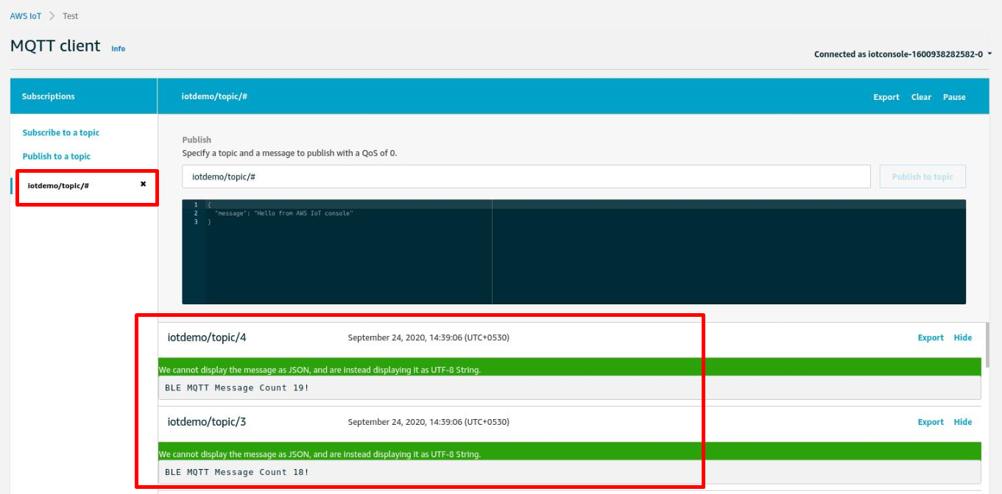

1. MQTT Message will display on the screen i.e. **“BLE MQTT Message Count 2!”**

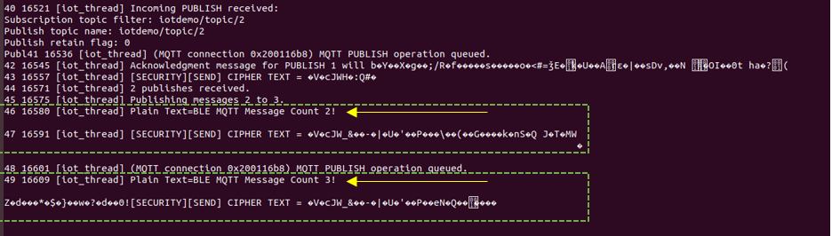

# OTA DEMO

## Setup AWS config in the STM32WB55 Source Code

1. The aws_demos application configured for OTA demonstrates an Over the Air update of the application firmware. The new firmware is downloaded via BLE to the STM32WB55 device and installed securely with the SBSFU bootloader.
2. Ensure aws_demos is configured for OTA demo in **config_files\aws_demo_config.h** in CubeIDE (or **vendors\st\boards\p_nucleo_wb55\aws_demos\config_files\aws_demo_config.h**):

#define CONFIG_OTA_UPDATE_DEMO_ENABLED

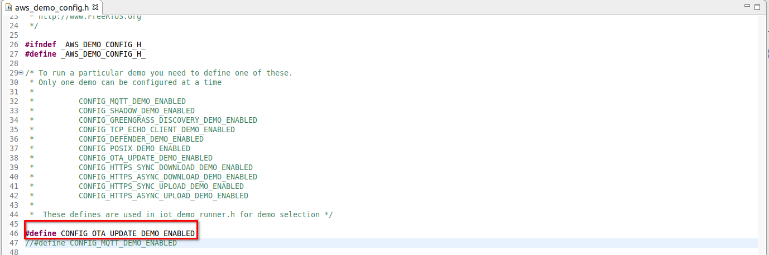

[**Note**: In addition, all the other CONFIG_*_ENABLED flags are commented.]

1. Ensure aws_demos is configured (especially the code signing certificate in **demos\include\aws_ota_codesigner_certificate.h**).
2. **For OTA:** Replace value of “**ota_cert**” variable inside the file **demos\include\aws_ota_codesigner_certificate.h** with pre-created certificate content (beginning with “-----BEGIN CERTIFICATE-----“):

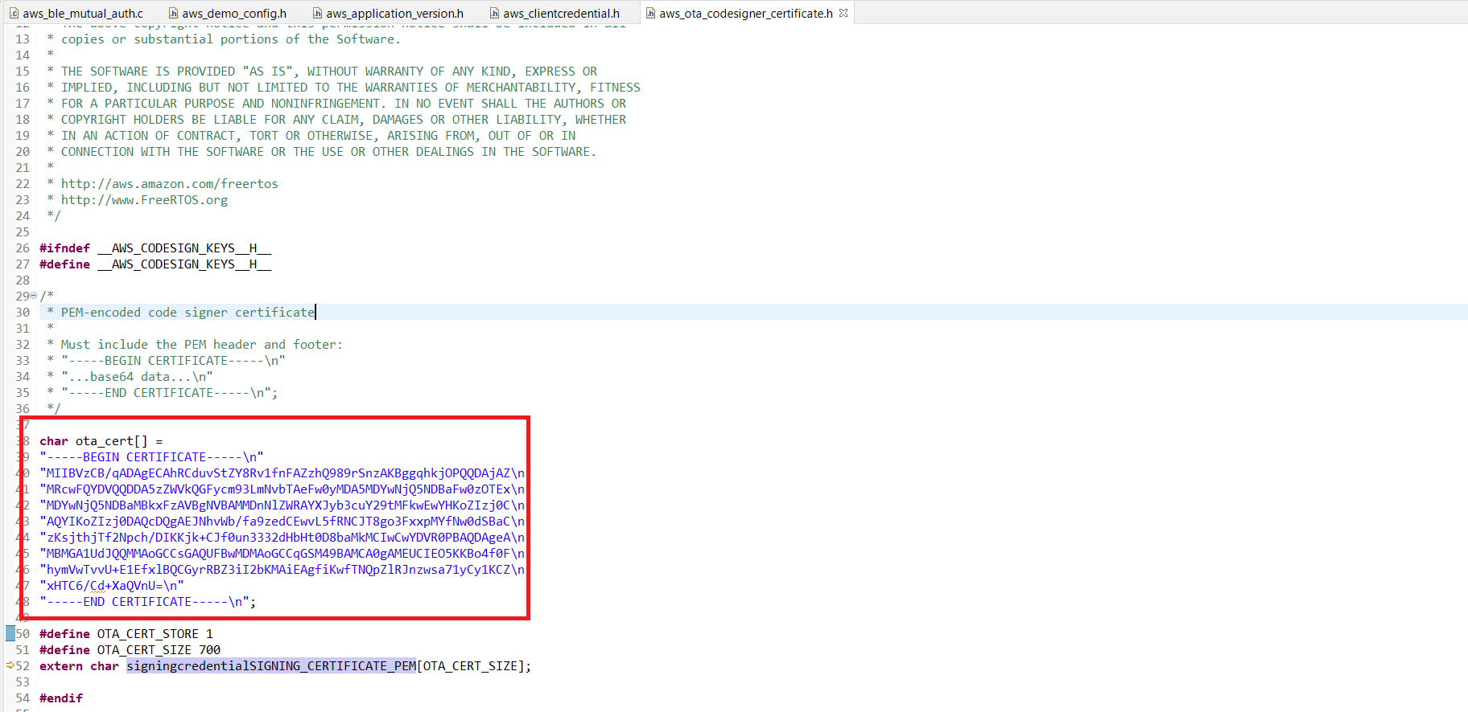

1. ONE time setup: set **OTA_CERT_STORE** macro to“1” for storing the data inside Optiga TrustM
2. Re-compile the **STM32WB55RG_Nucleo_AFR_demo** project as described in **section 4.1** and flash the binary on the STM32WB55 board as mentioned in the **section 4.2.**
3. Execute the binary to write certificate data into Optiga TrustM. The following print will be displayed on the console.

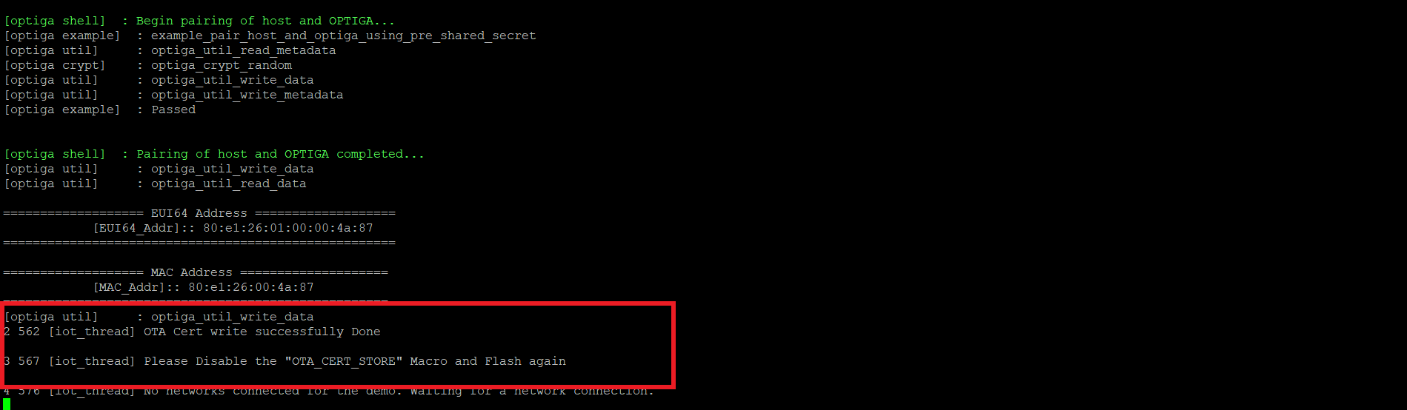

1. Stop the execution after certificate is written into Optiga, then set **OTA_CERT_STORE** macro to "0".

This will now allow the certificate to be read from Optiga TrustM

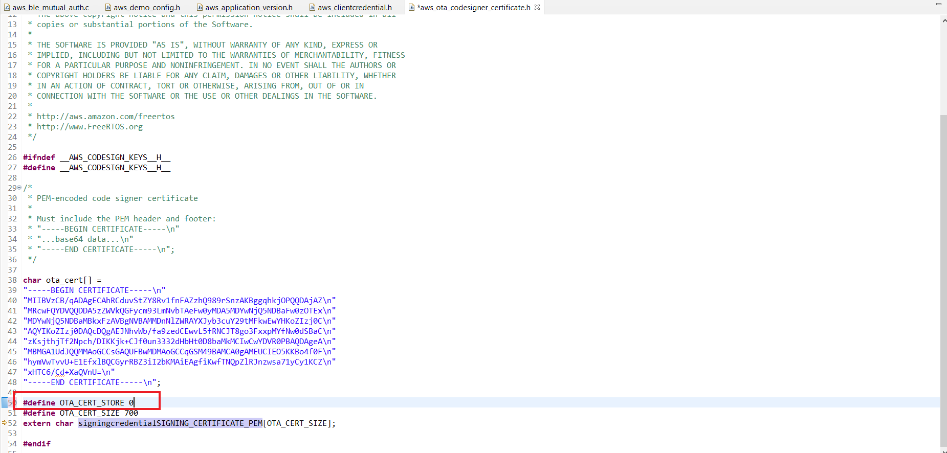

*Note :* ***OTA_CERT_STORE = 1*** *while running only for the first time.*

1. Compile the **STM32WB55RG_Nucleo_AFR_demo** project as mentioned in **section 4.1** and Flash the binary on the STM32WB55 board as mentioned in the **section 4.2.**
2. Following output will be displayed on the console if certificate is read successfully from the Optiga TrustM.

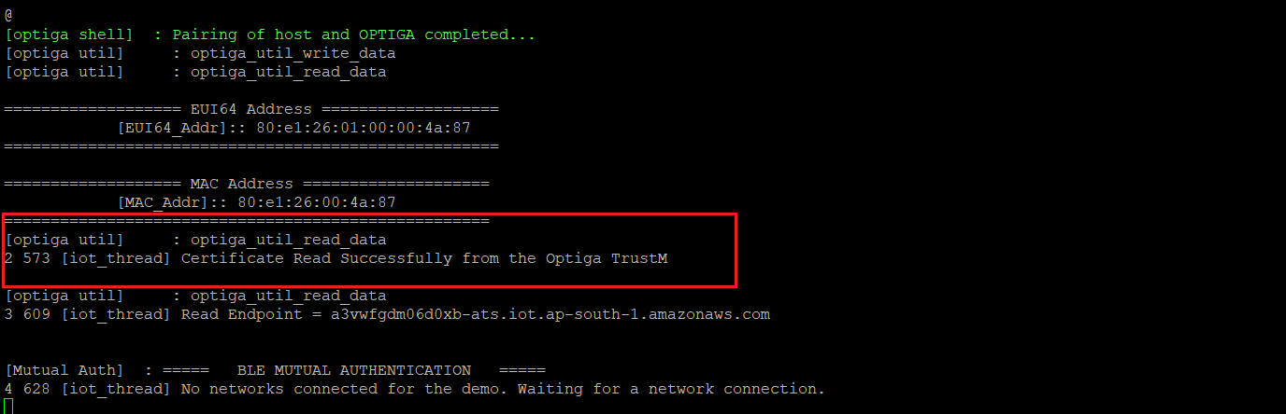

### OTA Firmware Version upgrade

1. This section covers the OTA update process, Firmware version needs to be upgraded in the STM32WB55 code and generating new *.sfb files to upload to an AWS S3 bucket. Detailed steps are mentioned below:
2. Presuming that the current version of the application is flashed to the STM32WB55 board. Now upgrade the firmware version in **demos/include/aws_application_version.h** as shown below:

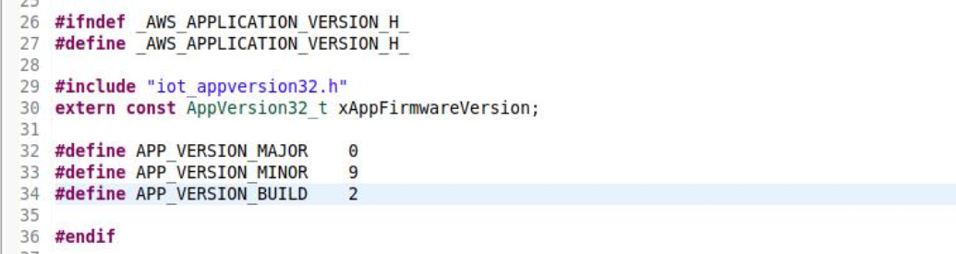

1. Now compile the **STM32WB55RG_Nucleo_AFR_demo** project as mentioned in **section 4.1** but **Do not Flash** the binary on the STM32WB55 board.
2. Please collect firmware from the **build\aws_demos.sfb**. Keep this firmware binary on the AWS S3 bucket (step mentioned in **section 2.3**)
3. The aws_demos project must be running on STM32WB55 Nucleo board and be connected to the mobile application.

### AWS configuration for OTA Job

1. On AWS console, create a FreeRTOS OTA update job (**IoT Core >> Manage >> Jobs >> Create**):

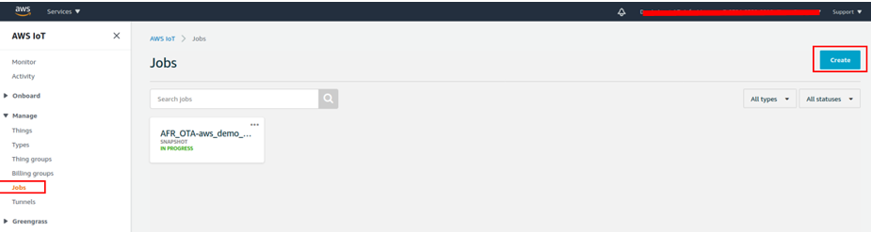

1. Select ‘**Create OTA update job’**

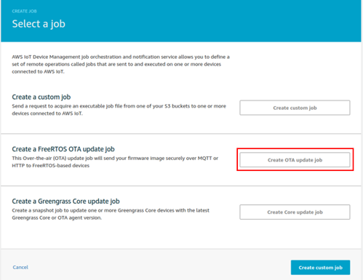

1. Select your “thing name” **ST32WB55** and press **Next**.

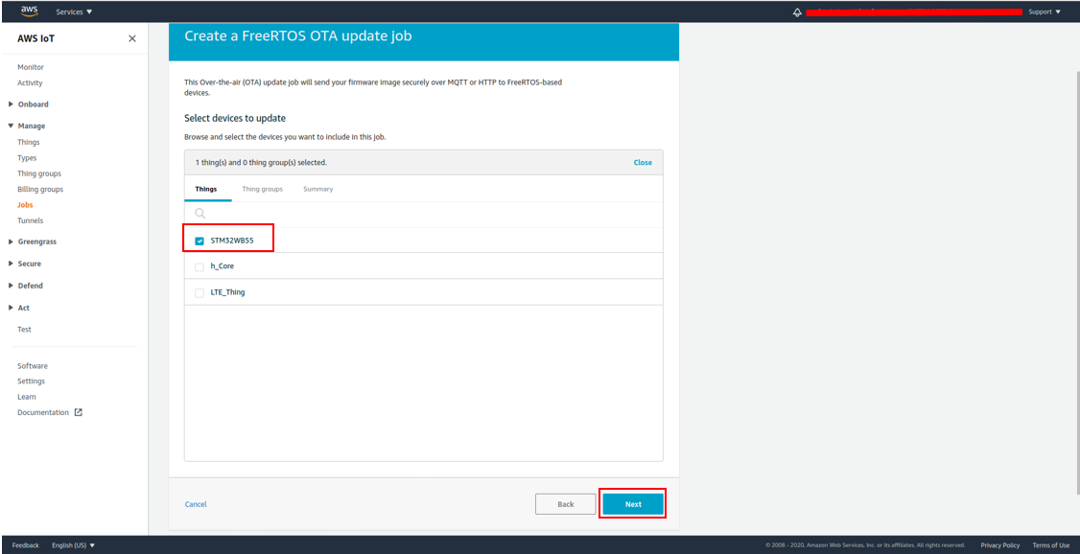

1. Select MQTT protocol for image transfer, (HTTP is not supported)
2. Select ‘**Sign a new firmware for me**’ option:

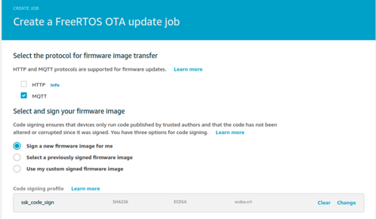

1. Select signing profile as **“prod_cert”.**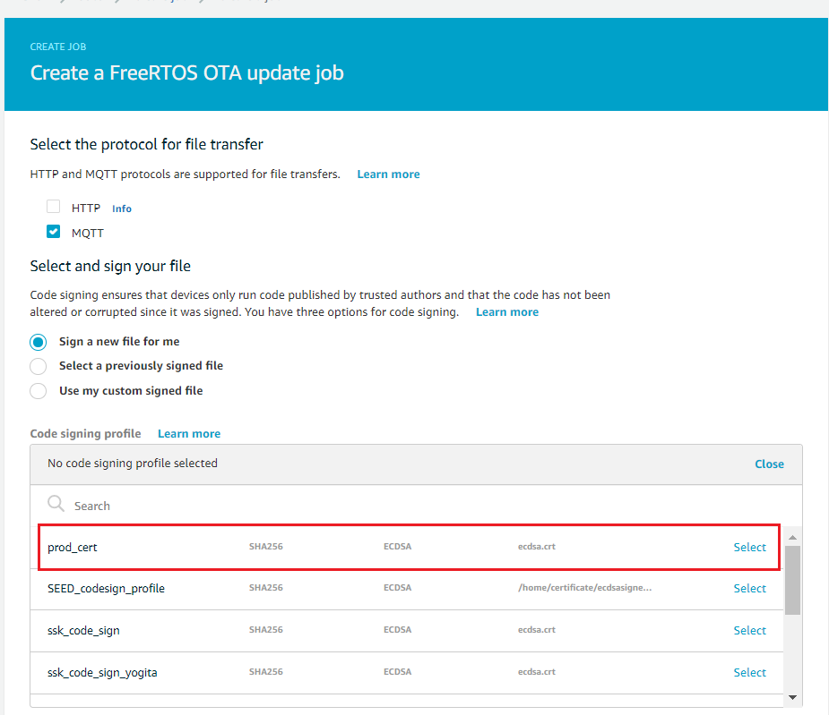
2. Select the aws_demos.sfb firmware file, which was uploaded on S3 bucket, and enter the destination pathname (e.g. firmware.bin)
3. Select the IAM role for OTA update Job which was created in **section 2.3** andclick on **Next.**

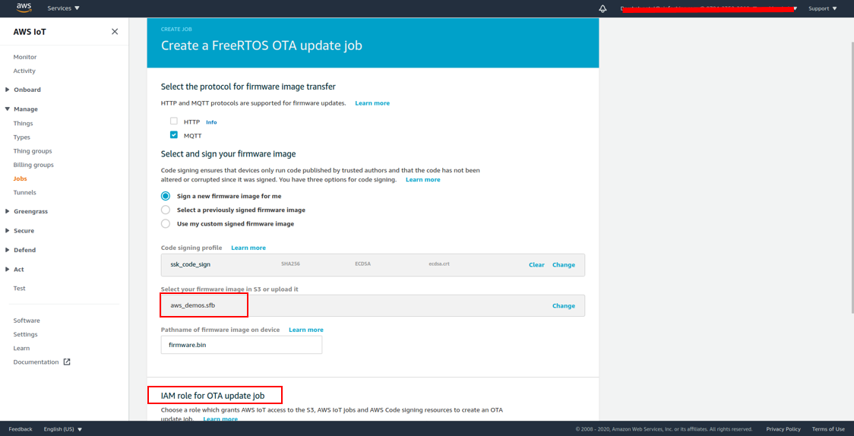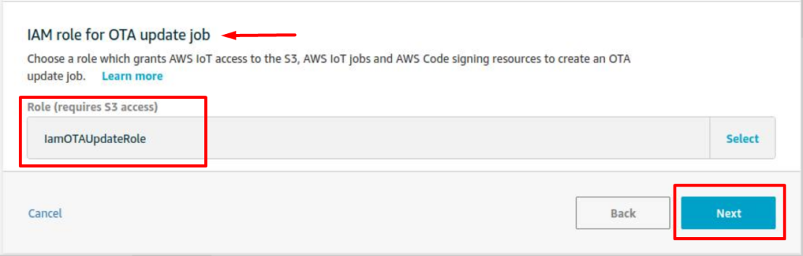

1. Enter Unique Job ID (e.g. Update_ver3) and Click on Create Button. User should see a **‘Success’** message displayed on the top of the page.

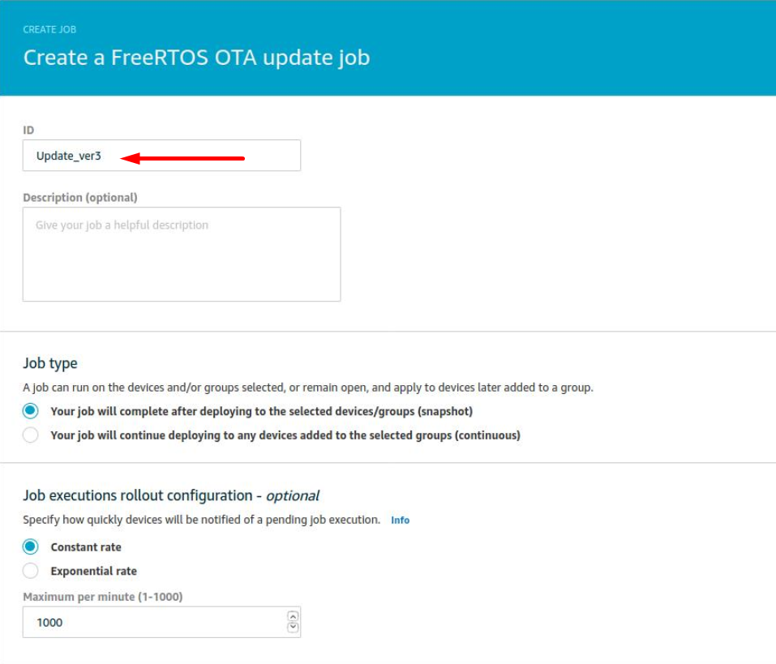

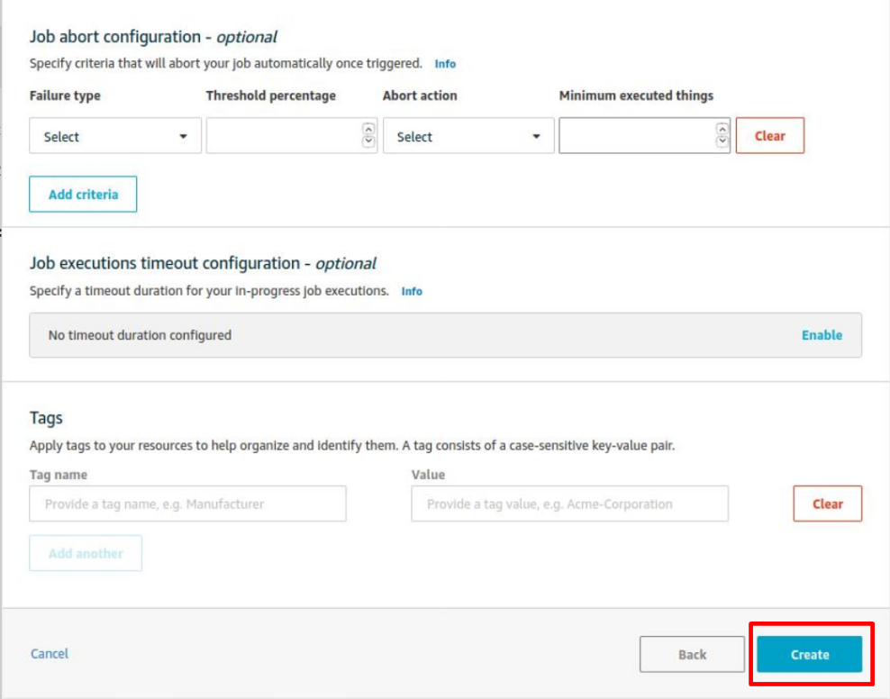

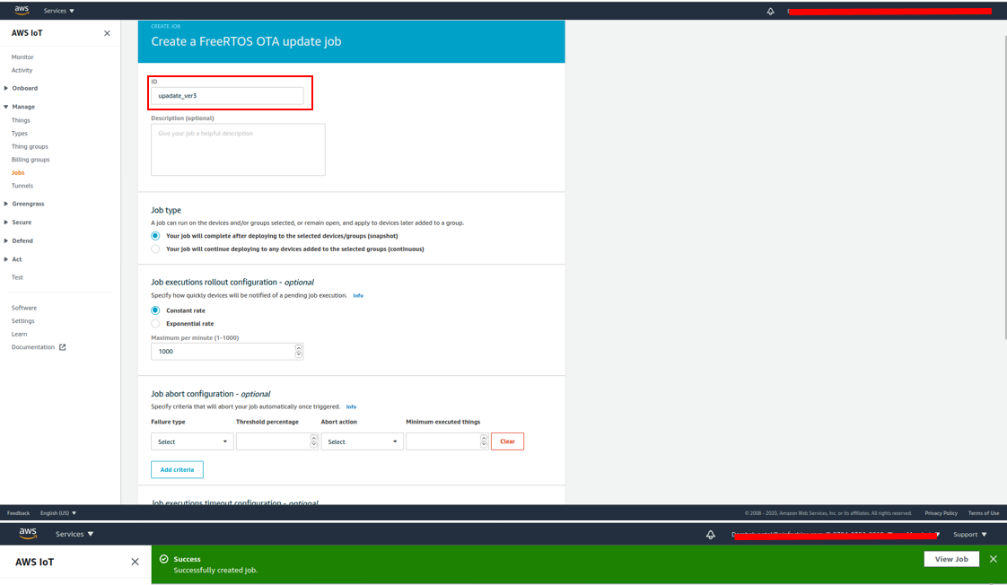

## Run OTA Demo

1. If you want to modify the Endpoint URL then follow the **step 2,** otherwise Reset the board and jump to **step 3**.
2. Press the **SW2 button** and Reset the board (By Pressing “**Reset**” [SW4] button as shown **in figure 2**). It will ask to enter endpoint URL on Serial console screen as below.

Paste the Endpoint URL here and press the “Enter” key on keyboard. (Note: Default Echo is OFF, so cannot see your Endpoint URL value.)

So, to verify that the correct endpoint URL was entered, on the serial console it will display the URL as shown below (with yellow redactions).



1. Click on the **SCAN FOR BLE DEVICES** button. Connect and Pair with STM32WB55 device. On the serial console to Press “Y” if passkey matches with mobile pair key.



1. During this demo, **Mutual Authentication** is enabled between the Mobile Device and STM32WB55. Only Authenticated devices can start communication, otherwise Mutual Authentication fails and logs out from the AWS Cognito Session in Mobile app.
2. To see the OTA Job status on AWS console, Open **AWS Console >> IoT Service >> Manage >> Jobs >> Select created Job (i.e. AFR_OTA-Update_ver3)**

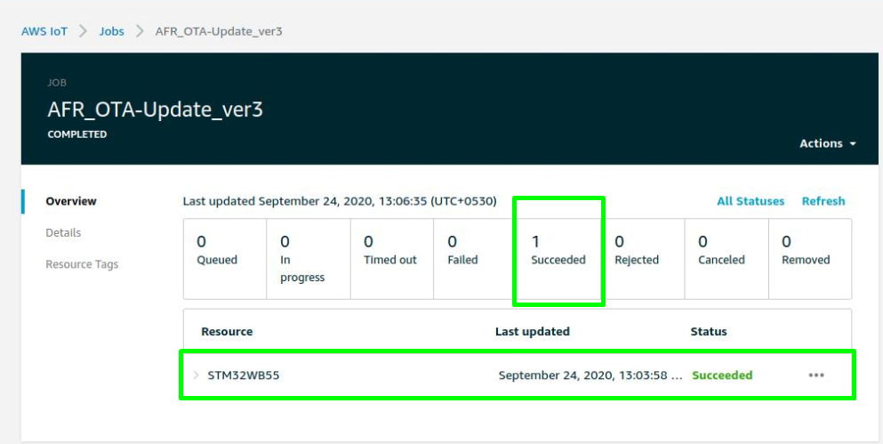

1. OTA Job and its packets shown in below screen capture:

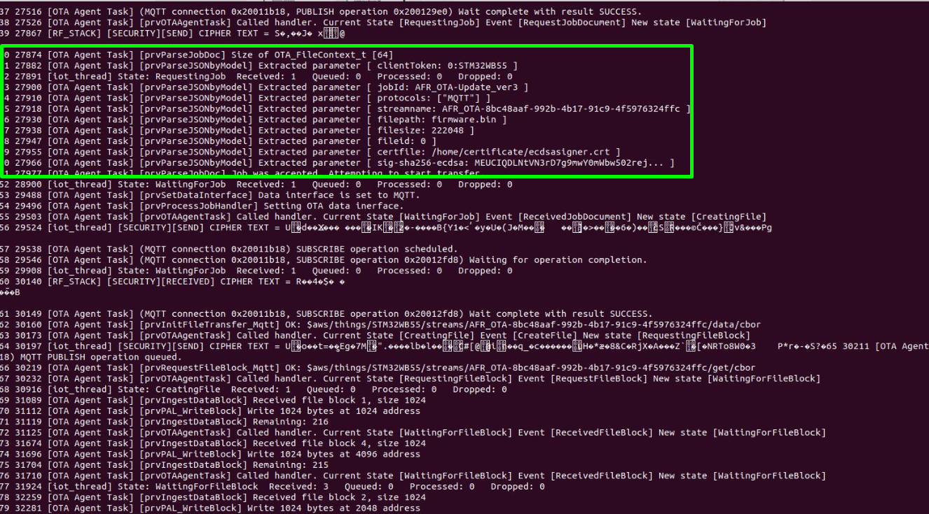

1. Verify the received Firmware and its signature as shown in below screen capture:

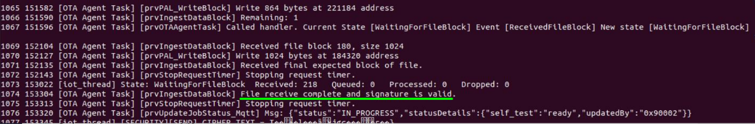

1. On Next reboot the Board will power up with newly upgraded firmware:



# References

[1] <https://aws.amazon.com/freertos/>

[2] [https://github.com/Infineon/OPTIGA™-trust-m](https://github.com/Infineon/optiga-trust-m)

[3] [https://www.infineon.com/cms/en/product/security-smart-card-solutions/OPTIGA™-embedded-security-solutions/OPTIGA™-trust/OPTIGA™-trust-m-sls32aia/](https://www.infineon.com/cms/en/product/security-smart-card-solutions/optiga-embedded-security-solutions/optiga-trust/optiga-trust-m-sls32aia/)

[4] <https://www.st.com/en/evaluation-tools/p-nucleo-wb55.html>